Paper Title
Name Surname (there can be multiple names)
Affiliation (faculty, university)
Address
e-mail address(es)
Supervisor: indicate the name(s) of your supervisor(s)

Abstract
Write the abstract here. This template should be used for all PESW submissions. Be sure to use the styles pre-defined in this template.
Keywords— component, formatting, style, styling

Introduction
This is how we write sections.

Subsection
This is how we write subsections.

Some Pre-defined Styles

Equations
Equations should be typed like this:
a  b    

Tables
Tables should be formatted like this:
- Table Type Styles
Table Head | Table Column Head
 | Table column subhead | Subhead | Subhead
copy | More table copyª
- Sample of a Table footnote. (Table footnote)

Figures
Figures should be formatted like this:
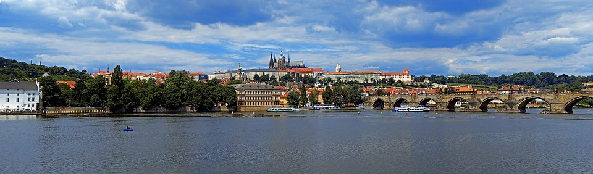
- Example of a figure caption. (figure caption)

Important Remarks
Be so kind and comply with this template. Especially, be so kind and:
- Do not use page numbering and footnotes
- Do not modify the A4 format, including the page borders

Page Limits
The page limits are as follows:
- Full-papers: up to 10 pages
- Abstracts: up to 4 pages
- Student posters: up to 2 pages

Acknowledgment (Heading 5)
You may write the acknowledgment here.

Paper Origin (Heading 5)
In the case this paper (or its part) has been published somewhere else, this section is mandatory. Indicate the original source here, please.

References (Heading 5)
- M. Young, The Technical Writer’s Handbook. Mill Valley, CA: University Science, 1989.
- …

